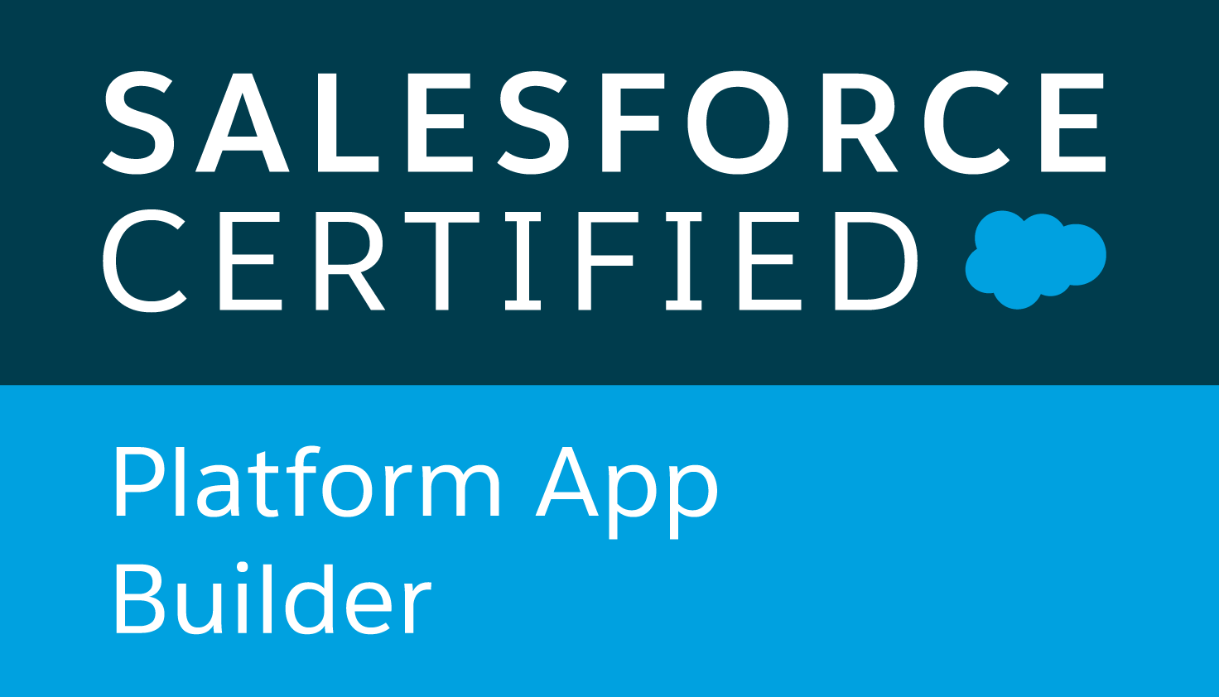

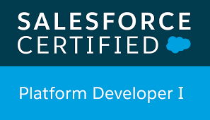

**Sai Pavan K**

**Salesforce Developer**

C:\Users\ADMIN\Downloads\Phone_Symbol-removebg-preview.png 5018301833

 spavank226@gmail.com

**OBJECTIVE:**

Experienced Salesforce Developer with **6+ years** in Salesforce development and administration, skilled in Apex, Visualforce, and Lightning Component Framework, aiming to drive seamless CRM solutions and enhance customer engagement.

**PROFILE SUMMARY**

* Proficient in **Apex** and **Visualforce** development for creating custom functionalities and enhancing user experience.
* Skilled in **Lightning Component Framework** and **Lightning Web Components (LWC)** for modern UI development and enhanced performance.
* Extensive experience in **Salesforce API integrations**, including **REST** and **SOAP APIs**, for seamless connectivity with third-party systems.
* Hands-on knowledge of **Salesforce Object Query Language (SOQL)** and **Salesforce Object Search Language (SOSL)** for efficient data querying and retrieval.
* Strong expertise in **Salesforce Security** models, including profiles, roles, permissions, and sharing rules for ensuring data confidentiality.
* Experienced in **Salesforce Flows** and **Process Builder** for creating declarative automation and optimizing business processes.
* Knowledgeable in **Salesforce DX (Developer Experience)** for version control, modular development, and continuous integration.
* Experienced with **Apex Triggers** to automate complex business logic and enforce data integrity.
* Proficient in **Change Sets**, **ANT Migration Tool**, and **Salesforce CLI** for seamless deployment and environment management.
* Skilled in **data migration** techniques, including **Data Loader** and **Salesforce Data Import Wizard**, for transferring data across environments.
* Familiar with **JavaScript** and **HTML/CSS** for developing and customizing Salesforce pages and Lightning components.
* Experienced with **Custom Objects**, **Fields**, **Page Layouts**, and **Record Types** for effective data modeling and organization.
* Strong understanding of **Salesforce Communities** for building customer-facing and partner-focused portals.
* Proficient in **Governor Limits** management, ensuring optimized performance within Salesforce’s multitenant environment.
* Skilled in **App Exchange package installation** and configuration to extend Salesforce capabilities and support client requirements.
* Proficient in **Salesforce Shield** for enhanced security, including **Event Monitoring** and **Field Audit Trail**, to safeguard sensitive data and meet compliance standards.
* Skilled in developing **Custom Metadata Types** and **Custom Settings** for storing application-level configurations, promoting flexibility and reusability across Salesforce environments.
* Experienced in **Salesforce Optimizer** and **Health Check** tools for identifying and addressing performance bottlenecks, improving overall system efficiency and security.
* Knowledgeable in **Apex Batch Processing** and **Scheduled Jobs** for handling large volumes of data and automating recurring tasks within Salesforce.

**EDUCATION**

* Masters in Computer Science from University of Arkansas at Littlerock, USA

**TECHNICAL SKILLS**

* **API Integration**: REST APIs, SOAP APIs, Bulk API, Streaming API, OAuth, SAML, Web Services
* **Data Migration Tools**: Salesforce Data Loader, Talend, Jitterbit, Informatica, MuleSoft
* **Middleware**: MuleSoft, Dell Boomi, Heroku Connect
* **SDLC**: Agile, Scrum, Collaborative and waterfall.
* **Version Control & Deployment**: Salesforce DX, Git, Bitbucket, Jenkins, ANT Migration Tool
* **CI/CD & Automation**: Jenkins, GitLab CI/CD, CircleCI, Automated Unit Testing, Test Classes
* **Database & Query Languages**: SOQL, SOSL, SQL
* **Authentication & Security**: SSO, OAuth 2.0, SAML, Salesforce Shield, Encryption
* **ETL Tools**: Informatica, Jitterbit, Talend, MuleSoft, Apache Camel
* **Data Management**: Data Loader, Import Wizard, Shield Platform Encryption, Field History Tracking
* **Integration Platforms**: MuleSoft, Dell Boomi, Informatica Cloud, AWS Lambda (for custom integration)
* **Salesforce Admin Tools**: Custom Objects, Profiles, Permission Sets, Sharing Rules, Role Hierarchies
* **Cloud Platforms**: Salesforce Platform, Heroku, AWS (for integration)
* **DevOps Tools**: Jenkins, Git, Bitbucket, ANT, CircleCI for continuous deployment
* **Reports & Dashboards**: Custom Reports, Dashboards, Report Types, Reporting Snapshots
* **Salesforce CRM**: Salesforce Classic, Salesforce Lightning, Salesforce Service Cloud, Sales Cloud
* **Programming Languages**: Apex, Visualforce, SOQL, JavaScript, HTML, CSS
* **Front-End Development**: Lightning Web Components (LWC), Aura Components
* **Salesforce Automation**: Process Builder, Flows, Workflows, Approval Processes, Validation Rules.

**WORK EXPERIENCE**

**Occidental Petroleum Corporation**, **Houston, Texas, USA| Salesforce Developer| May 2023 – Present**

OBJECTIVE: Occidental Petroleum Corporation (Oxy) is a major international energy company specializing in the exploration and production of oil and natural gas. I am focusing on customizing and developing Salesforce solutions to streamline energy and resource management processes, leveraging Apex, Visualforce, and Lightning Web Components (LWC) to enhance operational efficiency and support company-wide CRM initiatives.

Key Responsibilities and Achievements:

* Create tailored Salesforce solutions using **Apex, Visualforce, and Lightning Web Components** (LWC) to support energy operations and optimize workflows.
* Design and implement data integrations with Salesforce **APIs (REST, SOAP**) to connect with external energy data sources and internal systems.
* Leverage **Salesforce** Process Builder, Flows, and **Apex Triggers** to automate business processes and streamline operational tasks.
* Use **Lightning App** Builder to design and deploy custom applications that enhance user experience and align with Occidental’s unique requirements.
* Utilized Java and Visual Studio to develop and debug applications, integrated with Azure cloud services, managed tasks and workflows in Jira, and implemented e-signature solutions using DocuSign.
* Create real-time, customized reports and dashboards to provide insights on resource management and operations for decision-makers.
* Implement validation rules, duplicate rules, and data enrichment practices to maintain high data accuracy and integrity.
* Use **CI/CD** tools such as **Jenkins and Git** to manage code deployments and version control, ensuring smooth release cycles.
* Monitor and optimize **Salesforce** performance by identifying bottlenecks and implementing best practices to ensure system efficiency.
* Leveraged problem-solving and analytical skills to collaborate effectively with cross-functional teams, fostering strong interpersonal relationships to achieve project objectives.
* Work with IT and data teams to integrate Salesforce with on-premises and cloud platforms such as **AWS** for comprehensive data access.
* Develop complex data models within Salesforce to support Occidental’s data and analytics needs.
* Follow best practices for Salesforce development, including governor limits, coding standards, and efficient **SOQL** queries.
* Ensure all Salesforce configurations meet compliance requirements, such as **SOX**, relevant to the oil and gas industry.

ENVIRONMENT:Apex, Visualforce, Lightning Web Components, APIs, REST, SOAP, JSON, XML, Apex Triggers, Lightning App, Lightning App, CI/CD, Jenkins, Git, Salesforce, AWS, SOQL.

**Comerica Bank**, **Dallas, Texas, USA| Salesforce Developer| May 2022– Apr 2023**

OBJECTIVE: **Comerica Bank** is a prominent financial institution offering a wide range of financial services include retail banking, business banking, wealth management, and mortgage services. I designed and implemented custom solutions on the Salesforce platform to enhance CRM functionalities, including creating Apex triggers, Visualforce pages, & Lightning components.

Key Responsibilities and Achievements:

* Developed custom **Salesforce applications** using **Apex**, **Visualforce**, and **Lightning Components** to meet business requirements.
* Implemented **data integrations** between Salesforce and external systems using **REST API** and **SOAP API**.
* Customized Salesforce standard objects, including **Accounts**, **Contacts**, and **Opportunities**, to meet business workflows.
* Built and optimized **Apex classes and triggers** for automation and business logic execution.
* Developed custom **Lightning Web Components (LWC)** to enhance the user interface and improve end-user experience.
* Configured and customized **Salesforce Service Cloud** and **Sales Cloud** to streamline customer service and sales processes.
* Integrated **Salesforce** with third-party applications using middleware tools like **MuleSoft** and **Dell Boomi**.
* Designed and deployed **Salesforce Reports** and **Dashboards** to provide actionable insights and data-driven decisions.
* Utilized **SOQL** and **SOSL** queries to retrieve and manipulate data from Salesforce objects efficiently.
* Conducted **data migration** using **Data Loader** and **Workbench** to transfer legacy system data to Salesforce.
* Built and maintained complex **workflow rules**, **process builder**, and **Flow** automation to ensure business processes are streamlined.
* Configured **permission sets**, **profiles**, and **sharing rules** to enforce data security and ensure proper access controls.
* Performed **unit testing and regression testing** to ensure the stability and functionality of the Salesforce applications.
* Used **Git** and **Jenkins** for version control and continuous integration to manage code deployments in Salesforce.
* Monitored and optimized **Salesforce Lightning performance** to ensure a smooth and efficient user experience.

ENVIRONMENT: Salesforce, Apex, Visualforce, Lightning Components, REST API, SOAP API, Apex classes, triggers

MuleSoft, Dell Boomi, SOQL, SOSL, Data Loader, Git, Jenkins

**Max Life Insurance**, **Bangalore, India| Salesforce Admin/ Developer | Nov 2019 – Dec 2021**

OBJECTIVE: Max Life Insurance is one of India's leading life insurance companies, offering a wide range of individual and group life insurance solutions. My role is to managing system integrations, configuring workflows, and optimizing CRM processes to enhance sales, customer service, and operational efficiency, ensuring alignment with business objectives.

Key Responsibilities and Achievements:

* Design and implement custom Salesforce applications using **Apex, Visualforce, and Lightning** components to meet business requirements.
* Configure Salesforce objects, fields, record types, page layouts, and validation rules to tailor the **CRM** to business needs.
* Manage data imports/exports, data quality, and ensure efficient data migration using tools like **Data Loader and Dataloader.io.**
* Integrate Salesforce with external systems using **REST/SOAP API**, middleware tools like **MuleSoft** and third-party integrations.
* Utilize Change Sets, **Salesforce DX, and Git** for version control to manage code deployments across environments.
* Integrate **Salesforce** with marketing tools like **Pardot** to streamline lead generation, nurturing, and campaigns.
* Manage **Salesforce licenses**, subscriptions, and renewals for users and integrations, ensuring cost efficiency and compliance.
* Conduct **Salesforce Health Checks**, monitor system performance, and implement best practices to ensure optimal platform performance.
* Set up and manage Service Level Agreement (**SLA**) monitoring within Salesforce to track and ensure timely responses to client requests and claims.
* Develop and implement custom workflows specific to the insurance industry, such as underwriting approvals, policy issuance, and claims management.
* Regularly audit **Salesforce** data and user activity to ensure compliance with industry regulations, such as **GDPR** and insurance regulatory standards.
* Leverage Salesforce Einstein for advanced analytics and **AI-driven insights** into customer behavior and business performance
* Configure **Salesforce** for multi-currency and multi-language support to accommodate Max Life’s international operations and diverse customer base.
* Write **Apex test classes** to ensure code quality, and manage deployments using Salesforce **DX, Git**, and other tools to promote code from **sandbox** to production environments.
* Develop custom **Lightning pages** and apps for a seamless user interface tailored to the insurance business needs.
* Implement and manage **Salesforce** Platform Events to enable event-driven architecture and integrate real-time data into the **CRM** system.

ENVIRONMENT: Apex, Visualforce, Lightning, CRM, REST/SOAP API, MuleSoft, Salesforce DX, Git, Pardot, SLA, GDPR

, AI-driven insights, Apex test classes, DX, sandbox, Lightning pages.

**Asian Paints Ltd**, **Bangalore, India| Salesforce Admin/ Developer | May 2018 – Oct 2019**

OBJECTIVE: **Asian Paints Ltd.** is an Indian multinational company that specializes in manufacturing decorative paints, coatings, and related products. I involved in managing Salesforce environments, optimizing business processes implementing automation, ensuring data integrity, and providing end-user support.

Key Responsibilities and Achievements:

* Administer user profiles, roles, permissions, and licenses in Salesforce to ensure appropriate access control.
* Set up organization-wide default (**OWD**) sharing rules, roles, profiles, and permission sets to enforce data security and privacy.
* Customize Salesforce objects, page layouts, fields, and record types to tailor the **CRM** to business requirements.
* Develop and maintain custom reports and dashboards to provide actionable insights into business performance.
* Developed the **Lightning pages** with the needed **UI** designs. Performing the **UI** related activities including **Page layout** configuration. Ability to perform some Sales force administrative tasks and maintenance like user creation, etc
* Worked on the Web Services for enabling the data to be used outside the domain. Integration with **SAP**, **Oracle** and **Tibco**.
* Made the configurations in the applications time to time as per the requirement gathering.
* Experience on **Salesforce migration** from **Classic** to **Lightning**, **Apex classes, Workflows, triggers**, **Aura** platform, batch process, extension, controllers. Experience on Salesforce Lightning Utility Bar and Working **Version Control** tool **Bitbucket.**
* End to end flow of **Sales Order Management** for clients, including refunds, returns and reshipping.
* Working on **Continuous Integration** tool **Bamboo.**
* Experience working across various **SFDC** implementations covering **Sales Cloud, Service Cloud, and Call center**.
* Involved in Working with Standard Salesforce features like Objects, Workflows, Record Types, Page layouts, Workflow Rules, Case Assignment Rules, and Escalation rules, Validation rules, Profiles, Roles, Reports, and Dashboards etc.
* Experience on **Salesforce Lightning** UI using **Aura Components and LWC.** Experience on **Salesforce Lightning Communities** and **Audience** settings. Experience on **Salesforce** Lightning experience on creating reports.
* Used **SOQL**&**SOSL** with consideration to Governor Limits for data manipulation needs of the application using platform database objects. Preparing the documentation of the project and excellent communication skills.

Environment: OWD, CRM, UI, SAP, Oracle, Tibco, Aura, Bitbucket, Bamboo, Salesforce Lightning, SOQL&SOSL, SFDC.