**SHAIK BASHA SANDANI**

**Sr Project Manager**

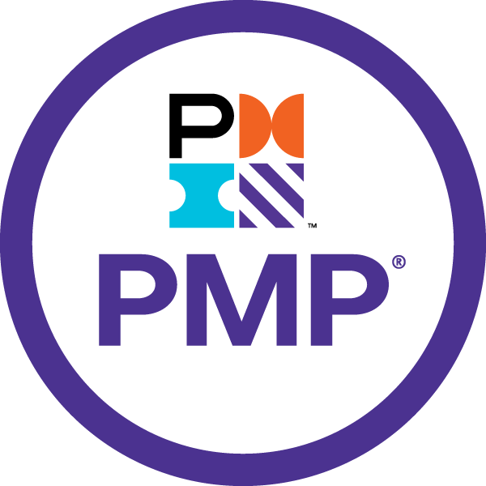 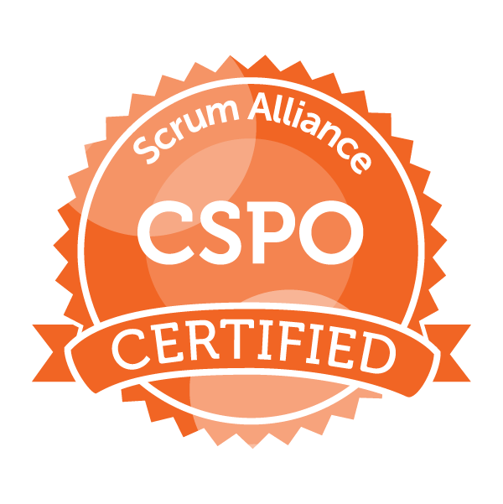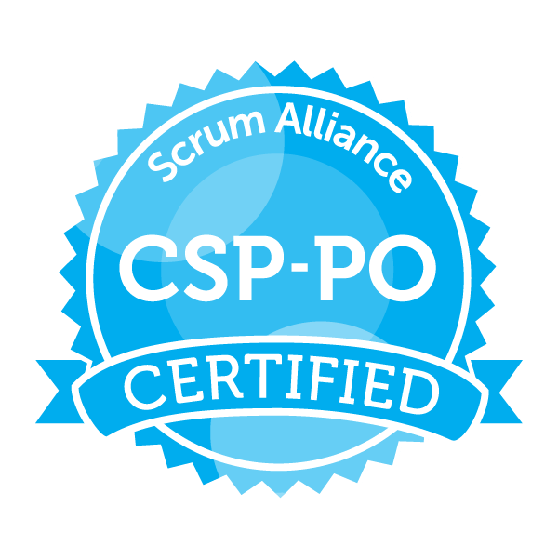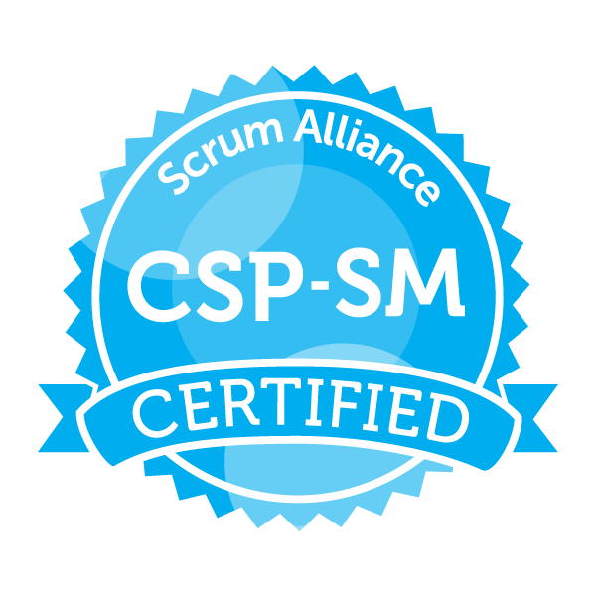 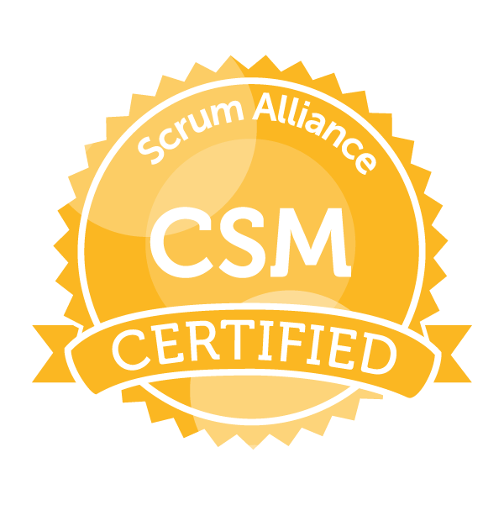

**PROFESSIONAL SUMMARY:**

* Overall 18+ years of experience, including **10+years with Project manager** and **8+years with QA**
* Proficient inproject management, test management, process management, Risk Management, Decision analysis, functional testing, webservices testing, QA automation frameworks and team management
* Strong knowledge in **creating execution dashboards, defining project specific KPI’s to track progress** and publishing the **summary reports to all stakeholders**
* Experience in implementing the client-oriented approach offering a full life cycle of solutions from conception to maintenance handling their long-term initiatives by providing **ROI value**.
* Exceptional in driving teams’ processes, designing strategies and in delivering technology-driven business solutions to meet strategic objectives.
* Experience in leading multiple teams working on cross functional areas and aligning them to organization business objectives and achieve defined client promoter NPS
* Proficiency in defining OKRs and KPIs for project teams that aligns to the vision of organization and client expectations.
* Proficient in gathering business, functional and technical requirements through interviews, questionnaires, business meetings and conference calls.
* Directed end-to-end **supply chain transformation projects**, including procurement, inventory management, and logistics optimization.
* Led cross-functional teams to implement data governance frameworks, ensuring compliance with organizational standards and regulatory requirements.
* Utilized tools like SAP, Maximo, or ServiceNow for tracking, reporting, and analyzing asset performance metrics.
* Expertise in conducting reviews, gap analysis audits, identifying the process lapses and suggesting the best practices.
* Implemented preventive maintenance programs across multiple facilities, extending equipment lifecycle and minimizing downtime
* Experience in working and implementation of Agile methodologies and scrum models; Certified Scrum Professional, Scrum Master, Product Owner from Scrum Alliance
* Certified PMP (Project Management Professional) from PMI board
* Developed and delivered 2 RPA projects successfully using UI PATH robotic automation implementing the features of orchestrator, Assistant, bot’s production, apps and action center.
* Experience in using google cloud platform in implementing the database Big Query, VM instances and cloud storage
* Experience in API testing using SOAP UI tool for REST, SOAP services in health benefits and mobile banking domain projects
* Expertise in trouble shooting the root cause by inspecting and validating the application logs using Kibana, Datadog and PUTTY

**AREAS OF EXPERTISE:**

* Agile methodologies • Onsite and offshore Coordination
* Driving efficiencies (financial & Workforce) • Negotiating Skills
* Project Estimations • Resource Planning & up skilling
* Project Management • PMO
* Risk Assessment / Impact Analysis • Delivery Efficiency
* Monthly Billing Invoices & Governance • Test Management
* QA Automation & Frameworks • Testing Proposals
* End to End testing methodologies • OKR’s & KPI’s
* HIPAA & EDI, Health plans & Enrollment • Max Files, Error Analysis
* Mobile Testing, Web Services, SOAP UI • Java Selenium, QTP, RPA UI PATH

**CERTIFICATIONS**

* Certified Project Management Professional (PMP) from PMI – (ID 2995019 - APR2027)
* Certified Scrum Professional (ID 000640776 – June 2026)
* Scrum Master (ID 000640776 – June 2026)
* Scrum Product Owner (ID 000640776 – June 2026)
* ISTQB Foundational Level Certified
* Value Labs Certified Automation Trainer

**TECHNICAL SKILLS**

|  |  |
| --- | --- |
| Programming Languages | Java, Python, PL/SQL, C, C#, VB, Groovy |
| Application/Web servers | ApacheTomcat8, JBoss, WebSphere |
| Relational Databases | Oracle, MySQL, Vertica, Big Query, PL/SQL, MongoDB |
| Internet/Web Technologies | HTML 5, XML, CSS 3, jQuery, Angular 6, Node JS 6. |
| Web Services | SOAP, REST |
| Cloud Environments | GCP, AWS, Azure DevOPS |
| IDE | Eclipse, PyCharm, Visual Studio |
| Operating system | Windows, Unix |
| Testing Tools | JUnit, JIRA, Selenium, SOAP UI, QTP, Studio 3T |
| Robotic Process Automation (RPA) | UI Path |
| Methodologies | Agile/Scrum, V& V, Waterfall |
| Version Control Tools | VSS, SVN, GIT |
| CI/CD Tools | Jenkins |
| Logging | Kibana, Datadog, Putty logs |

**PROJECTS**

**Client : United Airlines, Houston, Texas, USA Nov 2023 to Present**

**Role : Sr Project manager**

**Responsibilities**

* Designed the UI Path architecture and delivered the automated bots by implementing apps and action center
* Involving in all the sprint events sprint planning, daily scrum, sprint review and retrospective
* Played a vital role in building highly efficient teams for Benefit focus for their cost-efficient operations model from Offshore.
* Debugging the issues by checking the server logs and debugging through code
* Preparing and publishing the release closure summary reports
* Keeping abreast of developments in testing equipment, methods, and standards
* Involved in preparing Postmortem analysis
* Involved in project related trainings and document preparation.
* Performed regular cash reconciliations and prepared financial reports to monitor cash positions, identify discrepancies, and provide insights for decision-making.
* Identifying and reviewing the automation scope and suitable
* the development of data governance policies and procedures, streamlining data access, usage, and lifecycle management.
* Spearheaded the creation of comprehensive asset lifecycle management plans, optimizing procurement, maintenance, and disposal processes.
* Managed cross-functional teams to ensure successful delivery of Asset Management projects within scope, budget, and timeline.
* Managed global supply chain operations, ensuring alignment with business goals and adherence to cost, quality, and delivery standards.
* Oversaw the deployment of supply chain analytics tools, enabling real-time visibility and actionable insights for decision-making.
* Oversaw data migration and system upgrades for enterprise Asset Management platforms, ensuring data integrity and minimizing downtime.
* Directed data management projects, including data integration, cleansing, and migration, ensuring timely and accurate delivery.
* Working on estimations, test strategy, test plan and project dashboards
* Release planning and updating product backlog, EPICS and aligning user stories.
* Developed the data analysis workflow using Python and UI path tool for ongoing data validation
* Setting up the environments using GCP, VM ware and local environment
* Coordinated with vendors and contractors to manage procurement, service-level agreements (SLAs), and performance evaluation for facilities-related services.
* Developing the project initiation and planning documentation
* defining and getting approval on project specific goals, SLA’s and KPI’s
* Performing risk management potential risks, develop mitigation strategies, and monitor risk factors throughout the project lifecycle to minimize disruptions.
* Collaborated with cross-functional teams to define data management strategies, aligning with organizational goals and compliance requirements.
* Implemented metrics and dashboards to monitor data governance KPIs, providing actionable insights for continuous improvement.
* Collaborated with stakeholders to define and execute strategic sourcing initiatives, achieving cost savings through supplier negotiations.
* Ensured adherence to governance policies and regulatory requirements by conducting audits, reviews, and assessments of project activities and documentation
* Evaluating change requests, assessing their impact on project scope and timelines, and implementing changes while minimizing disruption to project progress.
* Utilized performance metrics and monitoring tools to track application performance, identifying and addressing issues to optimize efficiency and user satisfaction.
* Managing project budgets, allocate resources efficiently, and track expenditures to ensure projects are delivered within budget constraints.
* Coordinated the rollout of a new fraud detection system, improving the bank's ability to identify and prevent fraudulent activities

**Client : WebMD, New York, New York, USA Dec 2021 to Aug 2023**

**Role : Sr Project Manager**

**Responsibilities**

* Setting up the environments using GCP (Big query, VM’s and cloud storage), VM ware and local environment
* Managing project budgets, allocate resources efficiently, and track expenditures to ensure projects are delivered within budget constraints.
* Creating the dashboards in project management tools (ADO, JIRA) and publishing the project execution progress.
* Monitoring project timelines, identify and address bottlenecks, and adjust schedules as needed to ensure timely delivery of milestones.
* Evaluating change requests, assessing their impact on project scope and timelines, and implementing changes while minimizing disruption to project progress.
* Identifying and reviewing the automation scope and suitable framework (SOAP UI, Selenium)
* Developing the project initiation and planning documentation
* Developed and maintained facilities budgets, including forecasting expenses and optimizing cost allocation for capital projects.
* Directed the integration of ERP systems with supply chain processes, streamlining workflows and data sharing.
* Addressed and resolved conflicts or issues related to governance policies and procedures, ensuring effective resolution and alignment with project objectives.
* Partnered with IT teams to integrate governance principles into system architecture, ensuring data accuracy and accessibility.
* Managed large-scale data migration projects, utilizing tools such as ETL processes to ensure seamless transitions with minimal downtime.
* Implemented governance practices to monitor and ensure the quality of project deliverables, processes, and outcomes, aligning with organizational standards and goals.
* Identified potential risks associated with application deployments and updates, implementing mitigation strategies to prevent or minimize disruptions.
* Managed risk assessments and contingency planning to address supply chain disruptions, ensuring continuity in operations.
* Collaborated with stakeholders to define and prioritize asset management goals, aligning projects with organizational objectives.
* Conducted regular audits and compliance checks to ensure adherence to regulatory standards and asset management policies.
* Delivered training programs on Asset Management best practices, improving team competency and system adoption rates.
* defining and getting approval on project specific goals, SLA’s and KPI’s
* Performing risk management potential risks, develop mitigation strategies, and monitor risk factors throughout the project lifecycle to minimize disruptions
* Working on estimations, test strategy, test plan and project dashboards
* Release planning and updating product backlog, EPICS and aligning user stories.
* Delivered training and workshops to educate teams on data governance practices, increasing awareness and adherence to standards.
* Delivered training on supply chain best practices and tools to team members, enhancing operational expertise and efficiency.
* Delivered training to team members on data management best practices, fostering a culture of data-driven decision-making.
* Developed the data analysis workflow using Python and UI path tool for ongoing data validation
* Involving in all the sprint events sprint planning, daily scrum, sprint review and retrospective
* Debugging the issues by checking the server logs and debugging through code
* Preparing and publishing the release closure summary reports
* Conducted risk assessments and implemented contingency plans to address emergencies and ensure business continuity within managed facilities.
* Keeping abreast of developments in testing equipment, methods, and standards
* Involved in preparing Postmortem analysis
* Involved in project related trainings and document preparation.

**Client : Benefit Focus, South Carolina, USA Dec 2014 to Dec 2021**

**Role : Project Manager / Scrum Master**

**Responsibilities**

* Interacting with Business Users and stakeholders for project scope and requirements gathering & analysis
* Verifying the specifications provided by clients for corrections and documenting in finalizing the scope.
* Developing the project initiation and planning documentation
* defining and getting approval on project specific goals, SLA’s and KPI’s
* Performing risk management potential risks, develop mitigation strategies, and monitor risk factors throughout the project lifecycle to minimize disruptions
* Working on estimations, test strategy, test plan and project dashboards
* Release planning and updating product backlog, EPICS and aligning user stories.
* Managing project budgets, allocate resources efficiently, and track expenditures to ensure projects are delivered within budget constraints.
* Evaluating change requests, assessing their impact on project scope and timelines, and implementing changes while minimizing disruption to project progress.
* Identifying and reviewing the automation scope and suitable framework
* Developed the data analysis workflow using Python and UI path tool for ongoing data validation
* Involving in all the sprint events sprint planning, daily scrum, sprint review and retrospective
* Played a vital role in building highly efficient teams for Benefit focus for their cost-efficient operations model from Offshore.
* Debugging the issues by checking the server logs and debugging through code
* Preparing and publishing the release closure summary reports
* Keeping abreast of developments in testing equipment, methods, and standards
* Involved in preparing Postmortem analysis
* Involved in project related trainings and document preparation.

**Client : Monitise, London, UK Jan 2011 to Dec 2014**

**Role : Project Lead**

**Responsibilities**

* Interacting with Business Users for requirement gathering
* Involving in all the sprint related meetings starting from sprint planning to retrospective
* Involving in daily client scrum calls & updating the status
* Participate in Technical Review Meetings
* Assigning work among the team members and reviewing the team tasks
* Updating and reviewing the test cases prepared by Team Members
* API testing using SOAP UI tool and automated the cases using Groovy scripting
* Involved in developing automation script for regression testing using QTP, selenium
* Defect logging and Defect follow up in bug tracking tools
* Analyzing the defects using PUTTY server logs and communicating with DEV
* Involved in selenium automation and executed the regression scripts using selenium
* Preparing release summary reports/Status report
* Involved in preparing Postmortem analysis
* Involved in project related training and document preparation.
* Preparing PSRM & participating in PSRM presentation to client
* Involved in PMG audits for the CMMI process implementation

Preparing the test plan/strategy and testing estimations

**Client : SHPS Inc, Louisville, Kentucky, USA Aug 2008 to Dec 2010**

**Role : QA Lead**

**Responsibilities**

* Interacting with Business Users for requirement gathering
* Involving in all the sprint related meetings starting from sprint planning to retrospective
* Involving in daily client scrum calls & updating the status
* Participate in Technical Review Meetings
* Assigning work among the team members and reviewing the team tasks
* Updating and reviewing the test cases prepared by Team Members
* API testing using SOAP UI tool and automated the cases using Groovy scripting
* Involved in developing automation script for regression testing using QTP, selenium
* Defect logging and Defect follow up in bug tracking tools
* Analyzing the defects using PUTTY server logs and communicating with DEV
* Involved in selenium automation and executed the regression scripts using selenium
* Preparing release summary reports/Status report
* Involved in preparing Postmortem analysis
* Involved in project related training and document preparation.
* Preparing PSRM & participating in PSRM presentation to client
* Involved in PMG audits for the CMMI process implementation
* Preparing the test plan/strategy and testing estimations

**Client : AIS, Dallas, USA Aug 2007 to Aug 2008**

**Role : Sr Software Engineer**

**Responsibilities**

* API testing using SOAP UI tool and automated the cases using Groovy scripting
* Involved in developing automation script for regression testing using QTP, selenium
* Defect logging and Defect follow up in bug tracking tools
* Analyzing the defects using PUTTY server logs and communicating with DEV
* Involved in selenium automation and executed the regression scripts using selenium
* Preparing release summary reports/Status report
* Involved in preparing Postmortem analysis
* Involved in project related training and document preparation.
* Preparing PSRM & participating in PSRM presentation to client
* Involved in PMG audits for the CMMI process implementation
* Preparing the test plan/strategy and testing estimations
* Interacting with Business Users for requirement gathering
* Involving in all the sprint related meetings starting from sprint planning to retrospective
* Involving in daily client scrum calls & updating the status
* Participate in Technical Review Meetings
* Assigning work among the team members and reviewing the team tasks
* Updating and reviewing the test cases prepared by Team Members
* Involved in Database, functionality testing, System testing & Regression testing
* Involved in mobile testing using I phone, Android handsets, Emulators & DA and implemented the automation

**Client : MMT Inc, INDIA Aug 2006 to Aug 2007**

**Role : Sr Software Engineer**

**Responsibilities**

* Preparing the test plan/strategy and testing estimations
* Interacting with Business Users for requirement gathering
* Involving in all the sprint (Agile methodology) related meetings starting from sprint planning to retrospective
* Involving in daily client scrum calls & updating the status
* Participate in Technical Review Meetings
* Assigning work among the team members and reviewing the team tasks
* Updating and reviewing the test cases prepared by Team Members
* Involved in Database, functionality testing, System testing & Regression testing
* Involved in mobile testing using I phone, Android handsets, Emulators & DA and implemented the automation
* Debugging the issues by checking the logs using device specific tools
* API testing using SOAP UI tool and automated the cases using Groovy scripting
* Involved in developing automation script for regression testing using QTP, selenium
* Defect logging and Defect follow up in bug tracking tools
* Analyzing the defects using PUTTY server logs and communicating with DEV
* Involved in selenium automation and executed the regression scripts using selenium
* Preparing release summary reports/Status report
* Involved in preparing Postmortem analysis
* Involved in project related training and document preparation.
* Preparing PSRM & participating in PSRM presentation to client
* Involved in PMG audits for the CMMI process implementation

**EDUCATION**

**Master of Science in Information Technology May2006**

AAID UNIVERSITY, Allahabad

**Master of Science in Bio-Chemistry Oct 2002**

Madras UNIVERSITY, Chennai

**Bachelor of Science in Chemistry Apr 2000**

Sri Venkateswara UNIVERSITY, Nellore