Pavankumar Davanam  E-Mail: pdavanam@gmail.com | Mobile: 346-375-0790  Workday HCM/Integration | Oracle EBS/Cloud HCM | SQL/PLSQL | 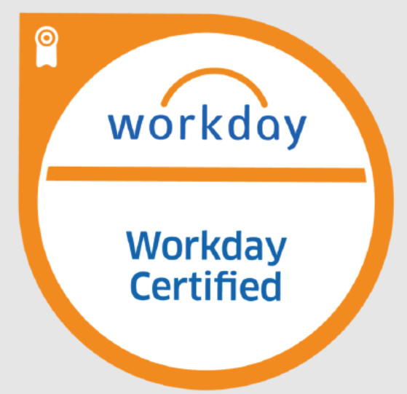
Objective:
Workday HCM Functional and Integration Consultant with over 16 years of experience in ERP systems, specializing in Workday implementations, configuration and support. Seeking to leverage my expertise in HCM modules, particularly in Core Hr, Recruitment, Compensation, Benefits, Time and Absence Management to drive strategic HR transformation within a dynamic organization.
Professional Summary:
- With over 16 years of extensive experience in ERP systems, I specialize as Functional and Integration Consultant in Workday HCM implementation, configuration, and ongoing support.
- Workday HCM Functional certified professional.
- Extensive Global experience, including onsite roles in Japan and Taiwan for the implementation of Workday.
- Proven experience in the architecture, design, implementation, development and testing of ERP technologies, including Workday HCM, Oracle EBS, Oracle Core HR, and Oracle Cloud HCM.
- Managed and executed migration projects from Oracle HCM(EBS) and SuccessFactors to Workday.
- Extensive experience and knowledge across the Telecom, Construction, Hospitality and Healthcare, Manufacturing, and Retail sectors.
- Good knowledge in Workday Functional HCM with responsibilities Supervisory Organizations, Staffing Models, Job and Positions, Compensation, Defining Business Processes and Security Groups.
- Implemented Workday Techno Functional and Data Migration using EIB, Core Connectors and Workday Studio in addition to creating Simple and Advanced reports.
- Designed and built both inbound/outbound EIB integrations in various segments of Workday system and worked with Core Connector, Cloud Connector (CCB), Report Design, Data Conversions iLoad’s, XML, XSLT, generated and developed Custom Reports, Advanced Reports as needed by business.
- Experience in maintenance and creation of Workday Supervisory Organizations, Locations, Positions, Cost centres, Cost Centre hierarchies and worked on the Object Management Systems like Role Based Security, User Based Security, Job Based Security groups, different staffing models, defining Hire restrictions to Job Management, Position Management and Headcount Management and creating Job Profiles, Job Families and Job Family Groups.
- In depth knowledge in Software Development life cycle experience such as planning, developing, implementing, Testing, Deployment and maintaining HR systems.
- Technical Functional experience in Oracle applications on various tools and release modules include Core HR, Payroll, Recruitment and Talent management, GL.AP,AR,INV and BOM
- Expertise in Requirement Gathering and Analysis, Design, Implementation and Maintenance phases.
- Developing and implementation of RICEF components in Oracle EBS Suite.
- Worked on APIs, SQL Loader, TOAD and Developing of Oracle Reports.
- Extensively followed agile software development process & extreme programming - test driven development, also worked on Waterfall Model implementation.
- A successful Team Player with strong communication and problem-solving skills to cope up with steep deadlines and emergencies with Flexible working hours and Quick Learner.
- Demonstrate exceptional understanding and experience in delivery methodologies and models tailored for software as a service (SaaS), coupled with excellent customer management skills, including working with senior executives in customer organizations and presenting to senior clients and conference audiences.
Certifications & Trainings:
- Certified in Workday HCM Functional. Workday Certified 32 and 33
- Got Trained on Workday Absence Management and Compensation.
- Actively involved in taking up the internal sessions to Workday and Oracle PL/SQL batches at Accenture top level for New Joiners.
- Trained in Oracle Cloud HCM and Absence Management.

Employment Details:

- Sr Workday Consultant for eSolutionsFirst from Jun 2024 to Till Date
- Functional Consultant in Workday for Conde Nast from October 2022 to Jan 2024.
- Functional Consultant in Workday for Shell from February 2022 to September 2022.
- Techno Functional Consultant at Accenture Services Pvt. Ltd., Bangalore from June 2006 to Jan 2022.

Professional Experience:
Project #: Jun 24 – Till Date
Working with eSolutionsFirst on HCM Modules.
Key responsibilities included supporting Workday HCM modules with BAU activities and working with enhancements, gathering business requirements and transforming them into solutions.
Additionally, responsibilities include identifying gaps in the product, suggesting solutions within existing functionality, and guiding users through new processes and technologies, ensuring they were comfortable with the system and understood the implemented functionality and processes.

Project #: Oct 22 - Jan 24
Working with Conde Nast on implementation of HCM Modules.
Key responsibilities included Implementing Workday HCM modules across five countries for Conde Nast, managing all phases of the implementation as a Functional Consultant. This involved engaging in ongoing discussions with global stakeholders to gather business requirements, provide status updates, and clarify needs to ensure alignment. Additionally, responsibilities included identifying gaps in the product, suggesting solutions within existing functionality, and guiding users through new processes and technologies, ensuring they were comfortable with the system and understood the implemented functionality and processes.

Project #: Feb 22 - Sep,22
Working with Shell Project on Core HR.
Key responsibilities included leading the implementation of HCM modules for multiple countries globally for Shell. This involved engaging in discussions with clients worldwide to gather business requirements, continuously providing status updates, and clarifying needs.Identifying gaps in the product, suggesting solutions within existing functionality, and implementing change requests. The role also required working closely with the internal team, assisting in understanding and resolving issues, and overseeing the entire process from start to finish..
Project #: May 2017 – Jan 2020
Worked for Tesco from Accenture to implement cloud HCM
Responsibilities included working on-site with Tesco for HCM Fusion Implementation, leading the QA team for Absence Management. Collaborated closely with Product Owners to provide solutions and make configuration changes in HCM and Absence Management for both office and store-related stories using Agile methodology. Worked alongside the QA team to prepare and execute test scripts in alignment with business requirements. Additionally, responsibilities included updating stories based on client meetings, conducting end-to-end testing with Business Owners, and consistently delivering high-quality work within deadlines, meeting all expectations without any escalations.
Project #: Apr 2006 – Apr 2017
Worked for Projects NBN Co, ITV and Skanska from Oracle Capability.
Responsibilities included serving as a Techno-Functional Lead in the development and support of RICE components. Successfully led the implementation of Workday from Oracle HCM at NBN Co., and the migration to SuccessFactors (SAP) from Oracle HCM at ITV. This role involved participating in multiple calls with business stakeholders to clarify requirements and implement changes accordingly.

Education: B.Engg(Computer and Information Science) Bachelor’s Degree from Visvesvaraya Technological University.

