shakeer ali

Professional Experience Summary

Professional Experience of over 16 years in Sales And Distribution experience in sectors like Medical Devices, Automotive Industry, Building Industry, Electronics Industry, Engineering Industry, Cement Industry, Textile Industry, Retail Industry, Service Industry, packaging Industry etc.

A Certified Consultant in SAP R/3 platform Version ECC 6.0, SAP S4 Hana Sales.

Worked on 7 Implementation Projects, and multiple Support engagements.

A Seasoned Functional Specialist experienced in all phases of Order to Cash life cycle (ASAP Methodology). Involved in multiple implementation using Agile Methodologies, SAP Activate, ASAP Methodology, global template, roll out and support engagements

Project Implementation skills include requirement gathering, As Is and To Be Documentation Functional and Technical Specification, Data Migration, Customization, Configuration, Testing, Issue Handling, Performing Cut over activities including Data migration and Hyper care
- Worked extensively on creating Business Requirement Documents and Functional Requirement Documents with the help of workshop sessions involving all the stake holders.
- Worked on various test phases like Unit testing, Functional Testing, Integration testing and assisted users with UAT

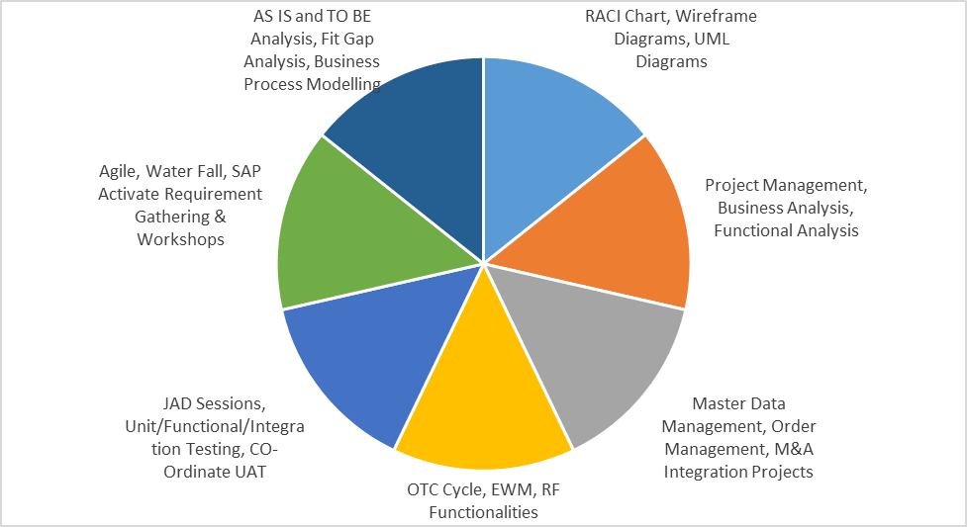

Sales and Distribution Experience Includes but not limited to following Process Areas:

Designing and Configuring:

Advanced Available to Promise (AATP), Back Order Process, Supply Chain Processes, Product Allocation Process
Advance Returns Management (ARM), Customer Complaints, Output Management using BRF+
Handling Unit Management, Batch Determination, Serialization,

Enterprise Structure:

All Organizational elements related to Sales and Distribution, Material Management, warehouse Management

Key Business Process:

Make to Order, Make to Stock, Intercompany Sales, Third Party Sales, Stock Transfer Order, Consignment Sales, Material Listings and exclusions, Free of Charge Deliveries, Free Goods Process, Invoice Correction Process, Returns. Material Packaging, Condition Contracts, Contract Settlement, Revenue Recognition.

Determinations:

Pricing Determination, Tax Determination, Partner Determination, Text Determination, Customer Maerial Info Record, Route Determination, Material Determinations, Shipping Point Determination, Revenue Account Determination, Sales Document, Delivery Document, Billing Document, Item Categories, Schedule Line Categories.

Configuring Basic Functions:

Availability Check, Transfer of Requirements, Dynamic Product Proposal, Incompletion log

Key Technical Configurations:

Sales Documents, Delivery Documents, Billing Documents, Copy Control Settings

METHODOLOGY : SDLC, ASAP Methodology, AGILE, SAP Activate
ERP Functions : ORDER TO CASH, PROCURE TO PAY CYCLE, EWM, RTR
BUSINESS PROCESS ANALYSIS : AS-IS & TO-BE ANALYSIS, Fit Gap Analysis, Fit to Standard
ERP Tools : : SAP (SD,MM,LE,CS) MIDDLE WARES (TIBCO, SAP PI)
DATA MIGRATION/TRANSFER:
Migration Cockpit(LTSM), EDI, LSMW, IDOC, Syniti tool, ETL Toos –Informatica, TIBCO, API, CPI
PROJECT TOOLS : MS SHAREPOINT, MS OFFICE, MS PROJECT, MS VISIO
ALM TOOLS : HP QUALITY CENTER QC/ALM, Microsoft ALM, Solution Manager

Certifications :

- SAP S/4 HANA Sales Certified Consultant—October 2022.
- SAP Certified Order to Cash consultant-- June 2013

Qualifications
- Master of Business Administration (MBA) from Osmania University, INDIA during 2004 –2006.
- B.SC form Sri Venkateswara University INDIA, during 2001 – 2004.

Experience:

Project : Brown Field Implementation – SAP ECC to SAP S4 HANA Upgrade.

Role: SAP S4 HANA Senior SD Consultant
Client: Kimberly Clark Corporation
Duration: July 2022 to Till Date
Location: Atlanta, Georgia.

Responsibilities:
- Always stayed Proactive and current with stakeholders in terms of information, Consulted and Collaboration which helped in improving Stakeholder satisfaction.
- Worked Closely with different business units to bring in value through processes and system knowledge and use the same for solving business IT needs
- Perform fit gap analysis of the requirements against current and targeted solutions.
- Worked on defining functional requirements, functional specifications, solution design, implementation of order to cash solutions.
- Designing test scripts and assisting users in executing them.
- Worked on various process designs related to CTC and Supply Chain area
- Worked on AATP, GATP, Product Allocation, Back Order Processing, Product Substitution.
- Worked on Condition Contract Management and settlement Management.
- Worked on Output Determination using BRF+
- Trained and Mentored end users to effectively use existing Order to cash solutions to solve business needs.

Project :
- ERP Transformation Project - SAP S4 HANA Implementation Americas
- ERP Transformation Project - SAP S4 HANA Implementation CMFT

Role: SAP S4 HANA Senior SD Consultant
Client: Zimmer Biomet
Duration: May 2019 to July 2022
Location: Warsaw, IN

Responsibilities:
- Always stayed Proactive and current with stakeholders in terms of information, Consulted and Collaboration which helped in improving Stakeholder satisfaction.
- Worked Closely with different business units to bring in value through processes and system knowledge and use the same for solving business IT needs
- Perform fit gap analysis of the requirements against current and targeted solutions.
- Worked on defining functional requirements, functional specifications, solution design, implementation of order to cash solutions.
- Designing test scripts and assisting users in executing them.
- Worked on various process designs related to CTC and LE area
- Worked on AATP, GATP, Product Allocation, Back Order Processing, Product Substitution.
- Worked on Condition Contract Management and settlement Management.
- Worked on Revenue Account Determination
- Worked on Data Extraction from Legacy systems, Data Cleansing, Data Transformation, Data Conversion, Data Migration and Data Transfer using ETL tools like Informatica, TIBCO, Syniti
- Trained and Mentored end users to effectively use existing Order to cash solutions to solve business needs.

Project : SAP S4 Upgrade
Role : Sr. Sales and Distribution Testing Lead

Client : Menasha Corporation
Duration : Jan 2017 to May 2019
Location : Neenah, WI

Responsibilities:

- Involved in SAP S4 Hana Implementation project.
- Interacting with Business to understand business process.
- Involved in preparing Test scripts and executing them
- Data Migration and Cut over Activities
- User Training
- Reporting any process gaps and correcting the configuration as required.

Project : SAP ECC 6.0 EHP4 Implementation and Support

Client : Firestone
Duration : January 2014 to Jan 2017
Location : Indianapolis, IN
Role : SD Lead

Responsibilities:

- Interacting with Key Business process owners to understand Business requirements and . Customizing the system as per the requirement.
- Reviewing the solutions proposed to client by team members.
- Monitoring and submitting weekly status reports to client management and other stake holders involved.
- Worked in areas like EDI process-Inbound and outbound IDOCS, Scheduling agreements, OTC business processes.
- Designed and Developed Functional specifications for EDI 830, EDI 850 and EDI 862.
- Supported day to day IDOC Transactional issues.
- Worked on shipment, TMS and Handling unit management process
- Worked on pricing, changes in pricing procedure, new condition tables, accesses sequence, and Condition types.
- Set up Rebates and commissions to be paid out periodically
- Worked on special business processes like Output determination, configuring new output types, Route Determination, Intercompany sales, Third party sales.
- Worked on Material Master, BOMS, Equipment Master, Serial numbers, Purchasing Info Record, Source List and Purchase requisition
- Resolution of support issues mainly in the areas of Quote to cash process including Quotations, Sales orders, Delivery and Billing.
- Worked extensively on modification of report logic, enhancements etc as per user requirement.
- Worked on the Scheduling Agreement and Transactions for Domestic and International Business and Revenue Recognition Process
- Maintenance calls and Service calls were customized via SAP Notification configurations
- Equipment, Maintenance orders, Service work orders were designed using SAP plant maintenance and Service Order processing functionality.
- Worked on Rebate management.
- Identifying root cause for recurring issues and proposed processes to eliminate them.

Project : AMS Support Project

Client : Tyco Electronics
Duration : January 2013 to Jan 2014
Role : Senior SD Consultant

Responsibilities:

- Responsible for handling tickets on daily basis adhering SLA guidelines.
- Interacting with the client and Key Users on to resolve the queries.Customizing the system as per the requirement
- Worked on processes like Output determination, Route Determination, Intercompany sales, Third party sales.
- Resolution of support issues mainly in the areas of Order Processing, Delivery and Billing.
- Worked extensively on modification of report logic, enhancements etc as per user requirement.
- Designed and Developed Functional specifications for EDI 810, EDI 850, EDI 830 and EDI 862.
- Worked on day to day issue with transactional IDOC issues.

Project : SAP ECC 6.0 Implementation

Client : Aditya Birla Yarn
Duration : September 2012 to December 2012
Role : SD Lead
Responsibilities:

- Collection of the requirements, creation of blue print, functional design documents.
- Configuration of Enterprise structure, Defining and assigning Organizational elements
- Creation of custom fields at sales order level.
- Configuration of the pricing procedures, VOFM routines, condition types, access sequences.
- Configuration of order types, item categories, schedule line categories, billing types. Account determination, Credit management.
- Designed and Developed Functional specifications for EDI 830, EDI 850 and EDI 862.
- Worked on day to day post implementation transactional IDOC issues.
- Configured Route Determination, output determination and text determination.
- Writing the test scripts, creation of the UAT documents.
Production support.
- Imparted training to SD users

Project: Shared Support Services
Role : Senior SD Consultant

Clients:

Gulf Cement Company—Ras Al-Khaima,UAE.

Union Holdings—Ras Al- Khaima,UAE.

RGPC—Doha, Qatar

Gorica—Abu Dhabi

Arkan Cements—Abu Dhabi

DB Power – Pune, India

Aris Global, Bangalore, India.

Upper India Steel, Ludhiana, India

Sierra south west, Arizona, USA.

Federal Foods—Dudai

Duration : November 2010 to August 2012

Responsibilities:

- Handling Responsibility as Project lead for Middle east Projects
- Responsible for assigning tickets on daily basis to the respective consultant adhering SLA guidelines.
- Monitoring the status of the Tickets
- Attending weekly and monthly review meeting with the client SPOC
- Presently involved in process improvement of technical and business activity of the Client.
- Interacting with the client and Key Users on daily basis to resolve their queries.
- Involved in creating global template solution for Cement Industry.
- Designed and developed Functional specification for EDI 850, EDI 810, EDI 856, EDI 860, EDI 830, EDI 862 etc., Involved in EDI mapping
- Supported day to day IDOC Transactional issues.
- Design and configuration of Service Notifications, Service Orders , Service Contracts and Return scenarios, Resource Related Billing
- Worked on Equipment Master, Serial Numbers, Material Master, Bill Of Materials
- Design and Implementation of Quote to Cash and Procure To Pay Processes including Third Party, Consignment ,Make To Order, Install Base Orders
- Worked on Process flow design for Consignment for Repair items and Loaner Products
- Worked on Shipment Processing, Route Determination and Shipment Cost Determination and Sales and Delivery Execution
- Worked on CS,MM,SD and PP integration and Transfer of Requirements, Planning, ATP, Product allocation .
- Worked on Shipment Documents, Leg determination, Shipping types, Transportation planning
- Equipment, Maintenance orders, Service work orders were designed using SAP plant maintenance and Service Order processing functionality.
- Worked on Service Orders, Equipment Master, Service Notification, Contracts, Periodic Billing

Project : AMS Support Project

Client : Davis Langdon
Duration : July 2010 to November 2010
Role : Senior SD Consultant
Responsibilities:

- Responsible for handling tickets on daily basis adhering SLA guidelines.
- Presently involved in process improvement of technical and business activity of the Client.
- Interacting with the client and Key Users on daily basis to resolve the queries.Customizing the system as per the requirement
- Handling the object transportation between systems.
- Supported day to day IDOC Transactional issues.
- Worked extensively on special business processes like Material determination, Free goods-with item and without item generation, Material listing and exclusion.
- Maintained material listing & exclusion process for not allowing the user to access certain materials only.
- Worked on Service Orders, Equipment Master, Service Notification, Contracts, Periodic Billing, Onsite Repairs, Delivery, Shipment Processing for Logistics Scenarios, Transfer Orders, Handling Units, Batch Management and Inventory Management,
- Worked on Resource Related Billing, Equipment Master.

Project : SAP Implementation Project

Client : Kalyani Forge
Duration : May ’09 to July 2010
Role : Senior SD Consultant

Responsibilities:

- Interacting with Business key users to understanding the Business processes, and prepared AS IS documents
- Providing SAP solutions to the existing business processes and prepared to be documents.
- Involved in Blue print document.
- Involved in process improvement of technical and business activity of the Client.
- Interacting with the client and Key Users on daily basis to resolve the queries.Customizing the system as per the requirement
- Handling the object transportation between systems.
- Configured Order types like Quotations, standard order, Rush order, Third party business process.
- Configured Pricing procedure, condition tables, access sequence and condition types.
- Configured Output determination procedures, output types, access sequence etc.
- Maintained material listing & exclusion process for not allowing the user to access certain materials only.
- Control for various business transactions within the context of billing like Cash Sales, Returns, Cancellation, Credit and Debit memos.
- Configuration of various Account Groups as per customer classification, and defined partner functions, Maintaining Partner Determination Procedures in various objects such as Customer Masters, Sales Document Header & Item.
- Prepared User Manual documents and involved in end user training activity.
- Involved in pre go live activities like ,cut over plan, preparing migration data and objects.
- Supported post go live activities.

Project : AMS Support Project

Client : MeadWestvaco
Duration : Aug ‘08 to April 2009.
Role : SD Consultant

Responsibilities:

- Resolution of support issues mainly in the areas of Order Processing, Rebate processing.
- Involved in Unit and Integration testing
- Documenting critical issues
- Provided support for exploding Bill of Material for a set of material with sub items by providing appropriate settings in customization for item categories in the sales document at the item level.
- Worked on credit management by defining credit control area, Risk categories, and Credit groups. maintained credit limits for the customers and updated in their Master Records as to which credit control area they belong.

Project: SAP Implementation Project

Client : Viskase Inc.
Duration : April 2007 to July 2008
Role : SD Consultant

Responsibilities:

- Understanding of client business process thoroughly and performed AS-IS and TO-BE study, Implementation scope, Identifying the Project Objectives, Project Organization roles, Client Strategies.
- Studying and Analyzing the Business Blueprint process by using the different kinds of implementation tools and participating in the steering committee meetings , following the Change management to finalize the business processes and taking sign off from the users.
- Creation of Enterprise structure in sales process by defining the respective sales organizations, Distribution channels, Divisions and other Organizational units and Assignment of Organizational units according to the structure of the company that has been specified by the client.
- Defined account groups to control field selection, partner functions and partner determination procedure,shipping point determination
- Customizing Document types-Quotations, Rush order, Third party orders, Delivery types, Item categories, Schedule lines categories, etc to process Sales, Delivery and Billing documents.
- Configured special requirements such as third party sales processes, consignment sales processes and inter-company sales processes etc.
- Configured the credit management involved in simple credit limit and automatic credit control area.
- Configuration of the customer master and sales views of the master data.
- Prepared User Sign-Off documents. Prepared user manuals and imparted end-user training
- Configured Availability check and Transfer of requirements.
- Defined pricing procedure at various levels. Created new condition types, access sequences and tables.

