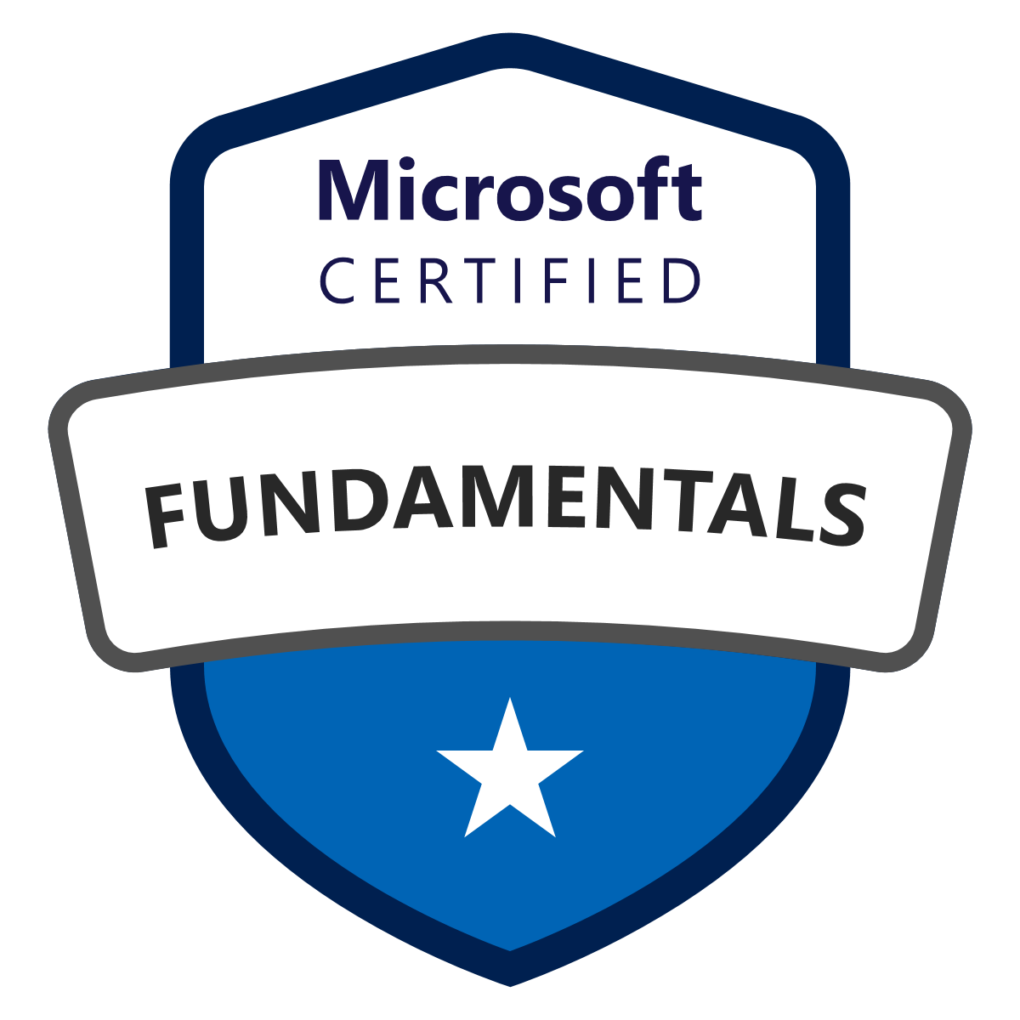
Aditya Vallapudas
Azure DevOps Cloud Lead Engineer
Email: shankar@coderepoz.com
Phone: (678)-890-8410
LinkedIn: https://www.linkedin.com/in/aditya-vallapudas1

Having around 8 years of experience in the IT Industry including Application Architecture, DevOps Engineering, Development, System and Communications Administration with a major focus on Azure, Continuous Integration, including Deployment, Containerization, Configuration Management, Build/Release Management, Virtualization technologies, Environment Management, Change Management and Server Maintenances which also includes Troubleshooting and Performance issues.

Performed, Executed, and Managed the following tasks, functions, and roles:
- Implemented Enterprise Integration architecture using Azure offerings like Azure Service Bus, Azure App Service, Azure Active Directory, Storage, Azure SQL server, Azure Virtual Machines and managed Azure Infrastructure Azure Web Roles, and Worker Roles.
- Proficient in Azure development, adeptly utilizing Azure services such as Azure Web Applications, App Services, Azure Storage, Azure SQL Database, Virtual Machines, Fabric Controller, Azure AD, Azure Search, and Notification Hub. Extensive experience in leveraging Azure Service Fabric for packaging, deploying, and managing scalable and reliable microservices and containers.
- Proficient in a diverse range of Azure services including Compute (Web Roles, Worker Roles), Databases, Networks, Internet of Things (IoT), PowerShell Automation, Monitoring, Key Vault, and Scheduling."
- Experienced in designing, configuring, and deploying solutions on Microsoft Azure, utilizing ARM Templates, AZURE PowerShell Module, and Azure CLI with a specific focus on achieving high availability and implementing auto-scaling mechanisms."
- Provided high availability for IaaS VMs and PaaS role instances for access from other services in the VNet with Azure Internal Load Balancer
- Skilled in strategic planning, deployment, continuous monitoring, and maintenance of Azure cloud infrastructure, encompassing multiple VM nodes to meet environment-specific requirements.
- Expertise in Cloud Migrations to IAAS Platforms like TFS, and Azure.
- Operated on Virtual machines and cloud services in the VNet to the Internet using Azure External Load Balancer.
- Handled the automated cloud infrastructure using Terraform which helped in saving time and manual configuration.
- Worked with Terraform key features such as infrastructure as a code, execution plans, resource graphs, and change automation and extensively used auto-scaling launch configuration templates.
- Proficiently utilized Azure Kubernetes Service (AKS) to deploy managed Kubernetes clusters within Azure. Demonstrated expertise in creating AKS clusters through the Azure portal, employing versatile deployment methodologies including Azure Resource Manager (ARM) templates and terraform.
- Experienced in developing APIs using Kubernetes to manage and specify container instances for cloud-based server deployments. Proficient in scheduling, deploying, and managing container replicas within Kubernetes node clusters.
- Created Smart HPA for Kubernetes application and configured it for APC Kubernetes
- Managed Kubernetes charts using Helm.
- Experienced with Event-driven and scheduled functions to trigger various resources.
- Created and used Microservices assessment asset for identifying the current level of best practices gaps of cloud/microservices practices.
- Worked on SQL and DynamoDB databases.
- Expertise in Migrating SQL databases to Azure SQL.
- Good knowledge of RDBMS Querying tools such as SQL Server.
- Experienced in branching, merging, and maintaining the versions using tools like Git, TFS, Gitlab, Bitbucket, and GitHub.
- Versatile experience encompassing multiple facets of Jenkins, ranging from plugin management, securing, and optimizing performance to analytics, scaling, and integrating code analysis and testing phases for comprehensive CD pipeline execution within Jenkins.
- Used Jenkins for Continuous Integration and deployment into the Tomcat Application Server.
- Extensively worked on Jenkins/Hudson and Bamboo for continuous integration and End-to-End automation for all builds and deployments.
- Implemented CI/CD for application using Jenkins as a CI tool for integrating different tools like GitHub, Maven, JUnit, and Nexus Artifactory and used Ansible as a configuration management tool for continuous deployment into testing, staging, and Production Environments.
- Executed Continuous Integration & Continuous Deployment process using Azure DevOps and Ansible to reduce the Deployment time.
- Expertise in using build tools like ANT and MAVEN for the building of deployable Artifacts such as WAR, EAR, BAR & JAR from source code and experience in using Nexus and Artifactory Repository Managers for Maven builds.
- Managed environments DEV, QA, STG (UAT), and PROD for various releases and designed instance strategies.
- Worked with Vagrant for testing Ansible plays and deployments.
- Wrote Shell Scripts, and Java Scripts to automate the package installation, web server, and instance configuration
- Responsible for maintaining GIT/SVN Repositories, and access control strategies.
- Experienced with DevOps/ Agile operations and tools (resolve merge conflicts, merge code, Build & Release automation, Service, Incident, and Change Management).
- Boosted network system, data availability, and integrity through preventive maintenance and upgrade.
- Good understanding of the OSI Model, and proficiency in configuring TCP/IP, DNS, NFS, SSH, SMTP, etc.
- Collected and Analysed metrics, logs, and events with Athena and Quick Sight
- Managed Azure resources by configuring Azure Diagnostics and Azure Monitoring.
- Develop implementations for cloud and microservices architectures and frameworks
- Regularly develop Frameworks, Pipeline scripts, and Cloud CLI scripts as part of migration.
- Developed YML and Shell Scripting for creating the build and release pipelines.
- Worked on reconfiguring existing release pipelines based on user requirements.
- Implemented Key Management System using Vault.
- Expertise in delivering APIs with .NET, Swift, NodeJS, and TypeScript.
- Used the Python's modules NumPy, matplotlib, etc.
- Release management and deployment of large-scale enterprise applications.
- Engaged in setting up JIRA as a defect-tracking system and configuring workflows, customizations, and plugins for the JIRA issue tracker.
- Integration with SonarQube for code coverage, and Selenium for automatic tests.
- Experience in maintaining Atlassian products like JIRA, Confluence, and Bamboo
- Designed and developed query service using Elastic Search and Kafka.
- Worked on Tomcat, JBoss, IIS, and WebLogic Application servers for deployments.
- Expertise in Windows System Administration for production, test, and development servers.
- Managed System Builds, Server Builds, Installations, Upgrades, Patches, Migration, and Troubleshooting of Server 2008, 2012, and 2012 R2 Servers.
- Installed and Configured RedHat Linux 6, and Solaris 10 operating systems on a large, distributed environment.
- Worked on HP SiteScope and CA Desk Manager to manage alerts from oncoming traffic/API response times.
- Used ServiceNow tool for managing incidents and change request tickets
- Worked on xMatters for paging assigned groups.
- Strong knowledge of Monitoring and log analytics tools like Nagios, SolarWinds, Dynatrace, Splunk, AppDynamics, Prometheus, Elasticsearch, Azure Monitor, and Grafana.
- Worked either independently or as part of a team, collaborating with various other teams for effective deliveries.

Certifications:
- Zoom Education Certificate ZTSC11831
- NIIT Certified: Java Enterprise Apps - Level 2 16APZZZZZ0289
- Microsoft Certified: Azure Fundamentals 7BD0B5-38LFEC
- Microsoft Certified: Azure Developer Associate 54C7B9-B3148R
- Microsoft Certified: DevOps Engineer Expert 6593CD-44EAD5

SKILLS AND COMPETENCIES

Cloud Technology | Microsoft Azure (Web Apps, Storage, SQL Database, Virtual Machines, Service Fabric, Active Directory)
Automation and Configuration Management Tools | Terraform, Ansible
CI / CD | Jenkins, Bamboo, Azure DevOps
Version Controls | Git, GitHub, Bitbucket
Monitoring Tools | Dynatrace, OpsGenie, SolarWinds, Splunk, AppDynamics, Prometheus, Grafana, Nagios, Azure Monitor.
Network Protocol | FTP/SFTP, SMTP, TCP/IP, HTTP/HTTPS, DHCP, NFS
Service Management Tools | CA Service Desk Manager, ServiceNow, Confluence, SharePoint
Web/Application Servers | Apache Tomcat, IIS, WebLogic, JBoss
Bug Tracking and Testing Tools | Jacoco, JIRA, Thread fix, Check Marx, SonarQube, JUnit, Selenium
Operating systems | Linux RHEL6.x/7.x, Windows 7/10 Server - 2008, 2012 R2
Containerization Tools | Docker, Kubernetes, Helm charts, Vagrant, OpenShift
Scripting Language | PowerShell, Bash, Python, YAML, XML, and JSON
Database Systems | SQL, DynamoDB, AppSync
Others | RabbitMQ, Argo CD, Kafka

PROFESSIONAL EXPERIENCE:
Flowers Foods, Atlanta, GA. May, 2023 – Till Date
Azure DevOps Cloud Lead Engineer
Responsibilities
- Integrated the Azure pipelines with Azure Artifacts and Azure Test Plans to accelerate the development and deployment of lifecycles.
- Worked on Automating, Configuring, and Deploying Instances on Azure environments and in Data Centers and migrating on-premise to Windows Azure using Azure Site Recovery and Azure backups.
- Worked on designing Azure Resource Manager (ARM) templates and created Azure Data Factory pipelines, linked services, triggers, and parameters.
- Terraform and Ansible were used to migrate legacy and monolithic systems to Azure Cloud.
- Have used service manager provider API which uses Terraform to create certificates on the Azure server
- Involved in deploying Kubernetes Cluster on Azure cloud with master/minion architecture and wrote many YAML files to create many services like pods, deployments, auto-scaling, load balancers, health checks, Namespaces, Config Map, etc.
- Used Azure Kubernetes Services to deploy a managed Kubernetes cluster in Azure and created an AKS cluster in the Azure portal, with the Azure CLI, also used template-driven deployment options such as Resource Manager templates.
- Expertise in Migrating SQL databases to Azure SQL.
- Deployed Azure SQL DB with GEO Replication, and Azure SQL DB Sync to the standby database in another region & fail-over configuration.
- Created Cache Memory on Windows Azure to improve the performance of data transfer between SQL Azure and WCF services.
- Worked on Event publishing for mass consumption and configured message flows.
- Worked on Azure DevOps for building a Continuous Integration (CI) and Continuous Deployment (CD) pipeline.
- Added DevOps capabilities such as Continuous Deployment from Azure DevOps, GitHub, Docker registry, and package management.
- Responsible for web application deployments over cloud services (web and worker roles) on Azure, using VS and PowerShell.
- Managed Azure resources by configuring Azure Diagnostics and Azure Monitoring.
Environment: Microsoft Windows Azure, Azure DevOps, Docker, Kubernetes, Terraform, Jenkins, GIT, SQL, Python, Jira, Confluence, OpsGenie, ServiceNow, Check Marx, SonarQube.

Humana Inc, KY Aug, 2020 – Apr, 2023
Azure DevOps Cloud Engineer

Responsibilities
- Responsible for setting up the Production Infrastructure. Development and deployment of the Python code into the infrastructure. Experienced in using Terraform to Automated Infrastructure and to deploy applications from satisfactory to Azure cloud
- Migrating On-premises virtual machine to Azure Resource Manager Subscription with Azure Site Recovery.
- Configured the Kubernetes provider with Terraform which is used to interact with resources supported by Kubernetes to create several services such as Deployments, services, ingress rules, Config Map, secrets, etc., in different Namespaces
- Managed Kubernetes charts using Helm.
- Managed Configurations and Deployments through Kubernetes
- Utilized Helm charts to package and deploy applications, simplifying the management of Kubernetes resources, including pods, services, and ingress controllers.
- Worked on Helm release management, including versioning, rollback, and release history tracking.
- Integrated Helm chart deployments into Azure pipelines, automating the application release process and ensuring consistency between development, staging, and production environments.
- Developed Infrastructure as Code (IaC), Configuration as Code (CaC), and Pipeline as Code for Azure using Jenkins, Terraform, Ansible, and ARM.
- Used Ansible Playbooks to set up and configure Continuous Delivery Pipeline and Tomcat servers.
- Managed Docker orchestration and Docker containerization using Kubernetes.
- Deployed Azure SQL DB with GEO Replication, and Azure SQL DB Sync to the standby database in another region & fail-over configuration.
- Follow-ups and maintaining SLA in Jfrog for Project Profiles and Penalty Boxes
- Expertise in using Jfrog Artifactory to archive the artifacts created at the end of the build and release process.
- Configured Security Scans and defect Tracking profiles in SonarQube and Check Marx.
- Manage releases to make sure the code goes live with Quality and Security.
- Integrated Jfrog tasks in Pipeline to analyze packages with Jfrog Xray and provide recommendations to users on the upgrade path.
- Extensive experience in Azure E3 Enterprise Mobility Suite of tools in MFA (Multi-Factor Authentication) and intone.
- Worked on Licensing and Creating and managing Virtual Machines with Storage – Share Drives
- Configured Azure Traffic Manager to build routing for user traffic Infrastructure Migrations: Drive Operational efforts to migrate all legacy services to a fully Virtualized Infrastructure.
- Create metrics (APM), monitoring and alerting OpsGenie with tasks/incident management among the teams.
- Coordinated with developers to establish and apply appropriate branching, labeling/naming conventions using GIT analyzed and resolved conflicts in GIT.
- Used Atlassian JIRA as an issue-tracking and ticketing tool.
- Configured Nagios to monitor the server’s performance in a test environment.
- Used Splunk to monitor/metric collection for applications in a cloud-based environment.
- Managed Azure-related alerts and Log Analytics to see the API calls.
- Used Confluence for documentation of plans, implementation of new services, and issues resolved
- Have been creating Test Environments using Vagrant by spinning up Virtual Machines
- Experience in creating and writing shell scripts (Bash), YAML, JSON, Python, and PowerShell for automating tasks
- Managed Kafka clusters both on Windows and Linux environments.
- Document application installations and infrastructure requirements and architecture in Confluence.
Environment: Microsoft Windows Azure, Ansible, Docker, Kubernetes, Argo CD, Helm, Jenkins, GIT, Python, Jira, Nagios, Splunk, Confluence, OpsGenie, Vagrant, Maven, ServiceNow, XenApp, Citrix, YAML, XML, JSON, Check Marx, Kafka, SonarQube.

Truist, Atlanta, GA Nov 2017 - Jul 2020

Azure DevOps Cloud Engineer

Responsibilities
- Hands-on Experience in designing and implementing Service Oriented Architecture underlined with Ingress and Egress using Azure Data Lake Store & and Azure Data Factory by adding blobs to lakes for analytic results and pulling data from Azure Data Lake to the Blobs.
- Developed and configured HTTP Triggers within Azure Functions, integrated with Application Insights for comprehensive monitoring and load testing of applications using VSTS. Employed Python API to efficiently upload agent logs into Azure blob storage
- Deployed Azure SQL DB with GEO Replication, and Azure SQL DB Sync to the standby database in another region & fail-over configuration.
- Wrote scripts for the provision of infrastructure management using Terraform.
- Implemented Terraform modules for deployment of various applications across multiple cloud providers and managing infrastructure.
- Maintain Windows and Linux servers hosted in Azure Cloud and on-premises
- Uploaded VHD files into Azure Storage Account using AZ Copy.
- Designed and implemented processes that support continuous integration and continuous deployment via Azure DevOps.
- Integrated Docker container Orchestration framework using Kubernetes by creating pods, Config maps, Deployments
- Used Kubernetes to manage containerized applications using its nodes, config maps, node selector services, and deployed application containers as pods.
- Deployed containerized applications on Azure Kubernetes Service (AKS) using Helm charts, streamlining the deployment process and ensuring consistency across environments.
- Deployed two-tier .NET, Python applications to Azure DevOps to focus on development by using services such as Repos to commit codes, Build Pipelines using PowerShell scripts for CI/CD and Test plans for unit test, deploy to App Service, Azure Application Insights collects health performance and usage data of the process, stored artifacts in blob storages.
- Created CI/CD pipelines for .NET, and python applications in Azure DevOps by integrating source codes GitHub, VSTS, and artifacts. Created deployment areas such as testing, pre-production, and production environment in Kubernetes cluster and configured App Insights, Prometheus, and Grafana monitoring dashboard for regular analysis.
- Worked on Shell Scripts, Python, and JavaScript to automate the package installation, web server, and instance configuration.
- Create Active Directory, DNS, join domain, Load balancer, SQL server, and Azure CLI tools and create Infrastructure as Code Pipeline to automate the deployment process.
- Troubleshoot the network and work with relevant technology concepts and experience with relevant technologies such as Load Balancers / DNS / SSL / Firewalls / DNS / Ping / Telnet / Trace route.
- Configuring monitoring by using Azure Monitor
- Monitoring managing and reporting the backups of the Azure Virtual Machines as per the company retention
- Developed automation solutions using PowerShell scripting for day-to-day operational tasks.
- Configured SonarQube application to perform a continuous inspection of code quality and static analysis of code to detect bugs, code smells, and security vulnerabilities.
- Manage source repositories, and perform merges in GIT.
- Maintain GIT repositories, and branching strategies and configure access control to the users.
- Create, maintain, and administrate GitHub repositories as source code management.
- Configured users and permissions for TFS, SharePoint portals, and Source Control Explorer folders.
- Usage of Grafana to visualize Prometheus metrics
- Develop new and enhanced Dynatrace plugins to meet the specific requirements of app teams.
- Involved in setting up JIRA as a defect-tracking system and configured various workflows, customizations, and plugins for the JIRA bug/issue tracker
- Experienced in upgrading and supporting Check Marx on Windows server
- Responsible for configuration of XML builds and verifying source files into the correct releases and mapping it to the checksum concept.
- Set up ETL for environments and configured RabbitMQ.
- Configuring AppDynamics and creating dashboards to monitor and gather required metrics and Expertise in troubleshooting and monitoring applications using AppDynamics.
- Installed and upgraded different versions of Tomcat/WebLogic.
Environment: Microsoft Windows Azure, Azure DevOps, Azure Active Directory, Microsoft Azure Storage, Azure SQL Database, Azure Monitor, SharePoint, Windows Server 2008, 2012/R2, PowerShell, Terraform, Grafana, Dynatrace, GIT, GitHub, Jira, AppSync, Thread fix, Check Marx, SonarQube, Junit, Jacoco, YAML, XML, JSON, RabbitMQ, Selenium, ServiceNow, AppDynamics, WebLogic.

Humana Inc, KY Oct 2016 - Sept 2017
DevOps Engineer

Responsibilities
- Creating Storage Pool and Stripping of Disk for Azure Virtual Machines.
- Migrating Virtual Machines and configuring for Users on Citrix Xen
- Involved in migrating on-premise cloud storage to Windows Azure using Azure Site Recovery and Azure backups.
- Created Docker files, Docker Images & Containers
- Created Cache Memory on Windows Azure to improve the performance of data transfer between SQL Azure and WCF services.
- ServiceNow Tool is used for change requests, Incidents, and Other generic requests to the various support teams.
- Utilized Apache Kafka to capture and process real-time and near-real-time streaming data.
- Managed Azure Infrastructure Web Roles, Worker Roles, Storage, Azure AD Licenses, and Office365.
- Performing load balancer activities using NetScaler
- Provided support for Domain related issues
- Allocations and taking backups with policies on Citrix Xen
Environment: Microsoft Azure, Azure DevOps, Azure cloud services, Azure Service Bus, Cosmos DB, Maven, Python, Ansible, Docker, Jenkins, GIT, Jira, Splunk, Confluence, ServiceNow, YAML, XML, JSON, Check Marx, Kafka, XenApp, Citrix, SonarQube.

Mother Blood Bank July 2015 – Oct 2016

Network Operations and System Administrator
Mother Blood Bank is an online blood bank service that aims to eradicate the scarcity of blood. This website was created to maintain the availability of blood with various blood groups and donor locations so that the distribution would be easy for hospitals and potential donors
Responsibilities
- Managed the databases and storage availability.
- Managing alerts, monitoring backend scripts, and setting the scope of application into the tool for monitoring.
- Creating tickets based on the template of the project, Filtering and Managing tickets, Checking the resolution or the status of the ticket, and assigning tickets to the groups in Service Desk Manager.
- Managed on-call services regarding problems in the network, and work-station and fixing them.
- Ability to handle System tuning, log maintenance, disk space management, etc.
- Engaged in developing shell scripts for automated installations to extract logs.
- Removing Customers having Good and conserving licenses by removing Good from Customers.
- Grouped sites with the owners and notified the changes in SharePoint upgrades during migrations.
- Documented software usage procedures, and process of installation of operating systems.
- Handling Disaster Recovery plans for the cold backup site.
- Developed shell scripts for running jobs on servers.
- Supported 24x7 for the production issues.
- Deployed code to the servers and handled network issues.
- Backed up data and handled server maintenance tasks.
- Hosting the website and managing the firewall and security aspects of the internet.
- Reporting and documentation are maintained to quickly resolve issues.
Environment: Bamboo, Jenkins, Prometheus, Bitbucket, JBoss, CA Service Desk, SQL

The above skills, competencies, and diverse experiences and expertise help me to position in a niche space.

